South Texas ISD Preparatory Academy Required Summer Reading 2022-2023 English 1
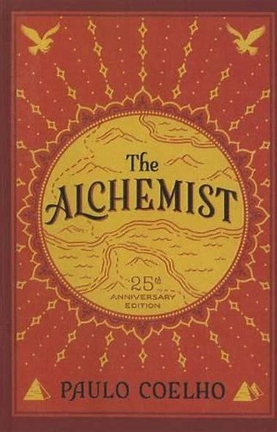

English 1 should:
- Purchase a copy of The Alchemist by Paulo Coelho.
- Download the The Alchemist Reading Guide which can be found at the school’s website:
https://preparatoryacademy.stisd.net/
- Read, reflect, and respond to the questions in the reading guide.
- Be prepared to electronically submit your completed reading guide during the first week of school.
- Be prepared to use your knowledge of the novel to do more sophisticated analysis and
writing activities during the first weeks of school.

Questions? Contact Mrs. A-G at patricia.ayala@stisd.net

